MED D - Address Changes and Out of Area (OOA)

Types of Addresses
Determine Who is Calling and the Reason
Address Changes Using RxEnroll Care
Address Changes in Participant Inquiry Tab
Address Changes for Incarcerated Beneficiaries
Note Templates
Email and Phone Number Changes
Related Documents

Description: The goal of this document is to provide the Customer Care Representative (CCR) with guidance on address changes and Out of Area (OOA) processing.

Types of Addresses
There are three types of addresses used for Medicare D beneficiaries:

- Residential address (Home, Permanent Address)
- Mailing Address
- Mail Order Pharmacy Address

The beneficiary’s residential address (also known as a home or permanent address) has a direct influence on their MED D Enrollment and Eligibility with their current Part D plan sponsor. An individual must reside within the plan’s service area to be eligible for Medicare Part D.

When updating a beneficiary’s Permanent Address and Mailing Address, updates are made in both the Medicare D Inquiry tab using the RxEnroll Care system AND the Participant Inquiry tab.

Note: System updates for Address Changes are effective immediately.

Top of the Document

Determine Who is Calling and the Reason

Perform the steps below to determine the specific piece(s) of contact information that should be changed for the beneficiary:
Step | Action
1 | Is the caller the beneficiary, POA, Legal Representative or Ship Counselor?  Note: A Third Party caller can call to report if a beneficiary has been incarcerated, a POA is not required.
1 | If the caller is… | Then…
1 | The beneficiary | Proceed to Step 2.
1 | POA, or Legal Representative information on file | Determine if the caller’s information matches the POA or Legal Representative details on the account in any of the following areas in PeopleSafe:  - High Priority Comments  - Privacy Lock  - Medicare D Inquiry Tab - View Comments  Refer to MED D - Appointed Representative Form (AOR) or Power of Attorney (POA).  Proceed to Step 2.
1 | POA, or Legal Representative Attests to Authorization | - An authorized representative may request a change of address on behalf of a beneficiary.  - If POA already on file and viewable in PeopleSafe continue with changes to contact information on file.  - If POA is not on file, authorized representative may verbally attest to being a legal representative. Refer to MED D - Obtaining a Verbal Attestation from an Authorized Representative. The CCR must document the following information and continue to assist them in submitting an address change and document in PeopleSafe:  - Document in notes the Authorized Representative’s First and Last Name  - What is the best phone number to reach you if documents are requested? (XXX) XXX-XXXX  - Please provide your full mailing address (street address, city, state, zip code + 4 if available)  - What is your relationship to the enrollee?
1 | POA, or Legal Representative Attests to Authorization | If… | Then…
1 | POA, or Legal Representative Attests to Authorization | Yes  (Documentation on file or Attestation completed) | Proceed to Step 2.
1 | POA, or Legal Representative Attests to Authorization | No  (Documentation is not on file or Attestation not completed) | - I apologize.  - You are not listed as an approved legal representative. Changes to the beneficiary’s contact information can only be completed by the beneficiary, POA or Legal Representative.
1 | Ship Counselor | If the Ship Counselor provides their unique ID, the Ship Counselor can update the address on the beneficiary’s behalf.  Proceed to Step 2.  Note: For questions on authenticating a SHIP Counselor refer to MED D - SHIP Counselor Calls For Part D Plans.
1 | Anyone else | Changes to the beneficiary’s contact information can only be completed by the beneficiary, a Legal Representative, or a Power of Attorney. Since you are not listed as an approved legal representative, we are unable to update the account at this time.  Refer to the MED D - Appointed Representative Form (AOR) or Power of Attorney (POA).  If the beneficiary is available and verbally provides permission, a change of address can be submitted by a non-legal representative. This is a one-time authorization.
2 | Determine the reason the beneficiary is calling.
2 | If... |  | Then...
2 | Address Change for Open Order, Refill Order/Mail Order or Single Use/Single Fill Only |  | Refer to Address, Email and Phone Number Changes.
2 | Permanent (Home/Residential) or Mailing Address Change, Reporting a beneficiary is incarcerated |  | Proceed to Step 3.
2 | Beneficiary Received an Out of Area letter |  | - Click on the Medicare D Inquiry Tab in PeopleSafe and click on the Last 12 months of Medicare Communication button to review the Out of Area letter.  - When MEDICARE is notified that a beneficiary may no longer reside in their SilverScript (PDP) or Blue MedicareRx (NEJE) Medicare Part D region, SilverScript or Blue MedicareRx (NEJE) is required to attempt to contact the beneficiary by phone or mail. The plan may be notified by Medicare through TRC or when the plan received a yellow sticker (return mail) from the USPS advising of a new address for the beneficiary.  Sample OOA letters:  - MED D - SilverScript OOA Sample Letter – English  - MED D - Blue MedicareRx (NEJE) OOA Sample Letter  Proceed to Step 3.
3 | Perform the following based on Client/Team:
3 | If... |  | Then...
3 | SilverScript(x9110) and NEJE |  | Proceed to Address Changes Using RxEnroll Care.
3 | Health Plans and EGWP |  | Refer to the CIF to determine if the plan handles the situations outlined in this document.
3 |  |  | If... | Then...
3 |  |  | Client | Follow direction provided in CIF.
3 |  |  | SSI | Proceed to Address Changes Using RxEnroll Care.
3 | Any other client |  | Proceed to Transferring Calls to Dedicated Teams Process.

Top of the Document

Address Changes Using RxEnroll Care

Perform the steps below:
Step | Action
1 | Click the Access RxEnroll Care link located on the Medicare D Inquiry Tab in PeopleSafe:  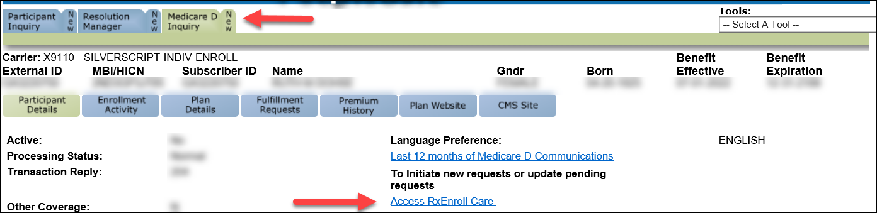  Result: RxEnroll Care screen displays.
2 | Determine if there are Action Areas.
2 | If... |  | Then...
2 | Yes |  | Select Address Change under Action Areas.  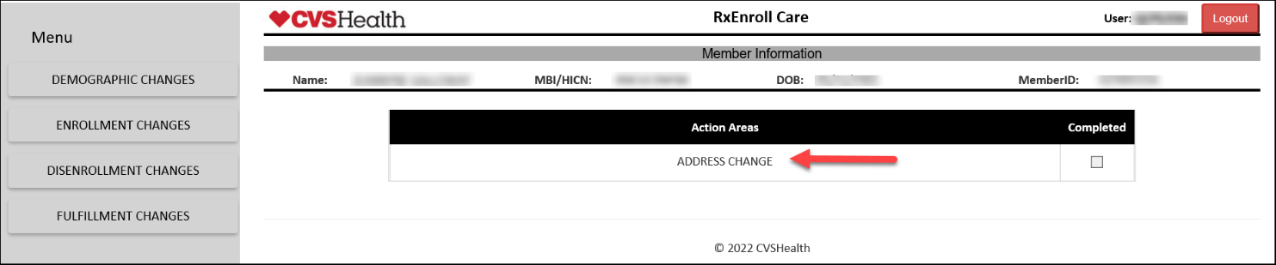  Result: The Address Information screen displays with the current address information on file for the beneficiary.  Proceed to Step 3.
2 | No, but the beneficiary requests to update address information |  | - Select Demographic Changes.  - Click on Address Changes.  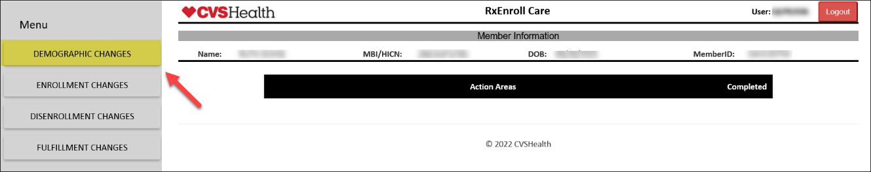  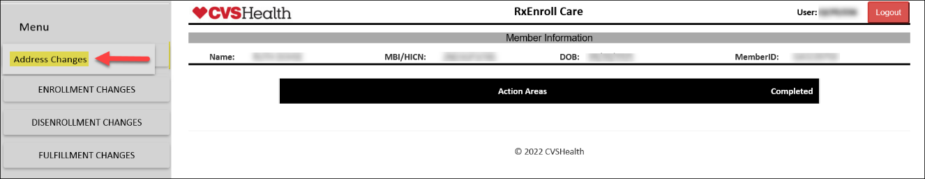  Result: The Address Information screen displays with the current address information on file for the beneficiary.  Proceed to Step 3.
3 | Review the Address Information and Current Address Information fields.  Note: If there is a pending OOA case for the beneficiary, it will display the date in red below the Address Information heading in which the beneficiary needs to confirm their Permanent (Home/Residential) address in order to avoid disenrollment.  Proceed to Step 4.  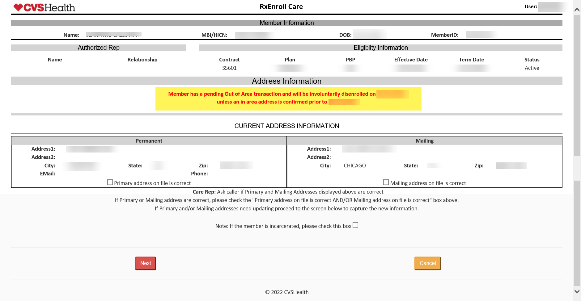
4 | Which address would you like to change today?  Based on the response, determine which address update is needed.
4 | If... |  |  |  |  | Then...
4 | The Permanent (Home/Residential) and or Mailing address are incorrect and need to be updated |  |  |  |  | - Do NOT check the boxes below the addresses.  Result: The Address Update screen will display.  - Proceed to Step 5.
4 | Only Permanent (Home/Residential) address is correct |  |  |  |  | - Check the Permanent address on file is correct box below the permanent address.  - Click Next.  - Proceed to Step 5.  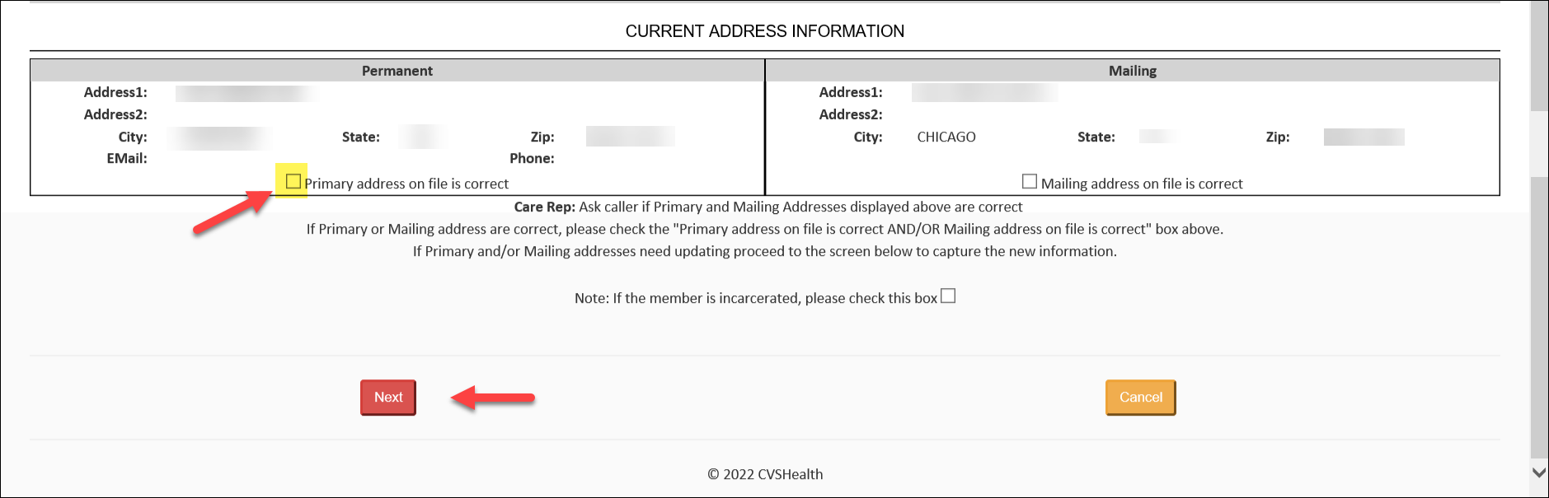  Result: The Permanent Address field will be grayed out in the address update screen.
4 | Only Mailing address is correct |  |  |  |  | - Check the Mailing address on file is correct box below the mailing address.  - Click Next.  - Proceed to Step 5.  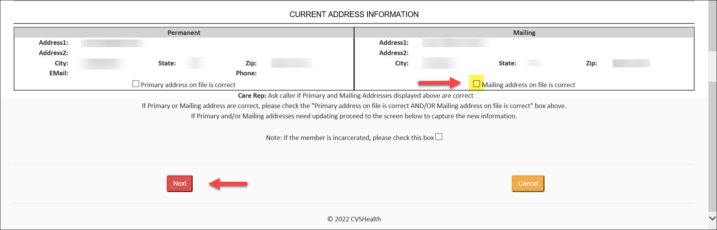  Result: The Mailing Address fields will be greyed out in the address update screen.
4 | Both the Permanent (Home/Residential) and Mailing address are correct |  |  |  |  | - Check the Permanent address on file is correct box below the permanent address.  - Check the Mailing address on file is correct box below the mailing address.  - Click Next.  I have confirmed that both your Permanent ((Home/Residential) address and Mailing address are correct. Is there anything else I can assist you with today?  - Exit the RXEnroll Care tool by clicking either Yes or No.  - Assist member with any other issues as needed.
4 | Beneficiary has or will move Out of the Country |  |  |  |  | - Confirm the caller’s identity and obtain the information requested on the care screen in RxEnroll.  Important Process Note:  - Foreign addresses must to be populated as follows:  - Address 1*: Street address and Apt No (123 E Main St, Apt 1)  - Address 2: City/Town  - City*: Country Name  - State*: Select FN from the dropdown menu  - Zip will be grayed out  - Email  - Phone  - Calendar Icon. Only populate if the date is for a future permanent move.  - This will initiate the OOA process to disenroll the beneficiary for the end of the month.  - Review the message with the caller that the beneficiary will need to reenroll in a Part D plan upon return to the Country.  - Click Next.  - Proceed to Step 5.
4 | Beneficiary request to cancel any updates during the call. |  |  |  |  | - Select Cancel.  - Read the language presented in the pop up box.  - Enter the following Comments in the pop up box: Beneficiary advised to cancel address change due to <Reason>.  - If needed provide Legal Rep or POA (Full name, address, and phone number, and relationship to the beneficiary).  - Click Submit.  - Log out of the RxEnroll Care application.
5 | Any stay that lasts more than 12 months is considered a permanent address change by Medicare. Would you like to update the address today?  - Based on the beneficiary’s response update the Permanent (Home/Residential), mailing or both addresses as needed. Complete ALL fields.  Note: If the mailing address is the same as the Permanent (Home/Residential) address, check the Mailing address same as permanent address box to auto populate all fields.  - Click the Next button when finished.  - Proceed to Step 6.  Important Process Notes:  - The address lines have a 30-character limit.  - Permanent (Home/Residential) Address requires a physical street address (should NOT be a P.O. Box.)  - SilverScript Only P.O. Box Exception - Exceptions can be made to accept a P.O. Box in cases including, but not limiting to, when an individual is:  - Homeless  - Resident at a Homeless Shelter  - Resident at a Women’s Shelter  - Rural area where only a P.O. Box is provided.  - EGWP Beneficiaries who verbally verify residence within the United States or any of its territories, including Puerto Rico  - It is important to note the reason in the comments as to why the beneficiary provided a P.O. Box as a Permanent (Home/Residential) address and that the plan verified that the beneficiary resides within the region.  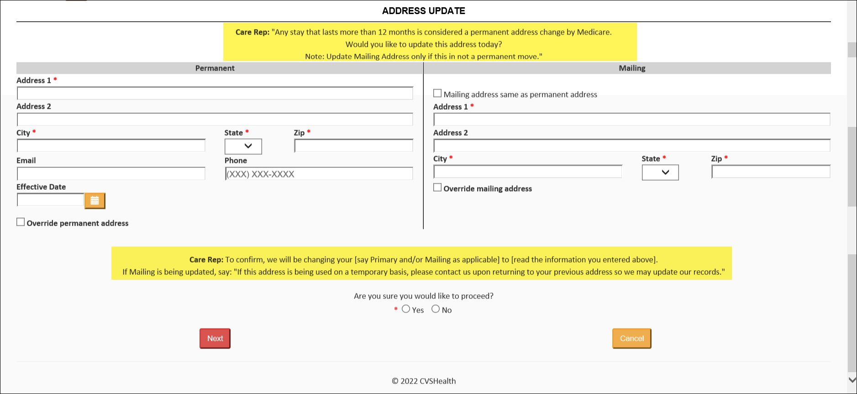
5 | If... |  |  |  | Then...
5 | Permanent (Home/Residential) Address Change |  |  |  | Populate all fields under the Permanent Address Section. An Asterisk (*) indicates a mandatory field. The address lines have a 30 character limit.  - Address 1*: Street number and Street name (123 Main St.)  - Address 2: Apartment Number, Lot Number and C/O information (Apt 2, Lot 15, C/O John Deere)  - City*  - State* (if the move is a foreign move, select FN from the dropdown menu)  - Zip*  - Email  - Phone  - Calendar Icon. Only populate if the date is for a future permanent move.  Reminder: Permanent (Home/Residential) Address requires a physical street address (should NOT be a P.O. Box.)  SilverScript Only P.O. Box Exception  - Exceptions can be made to accept a P.O. Box in cases including, but not limiting to, when an individual is:  - Homeless  - Resident at a Homeless Shelter  - Resident at a Women’s Shelter  - Rural area where only a P.O. Box is provided.  - EGWP Beneficiaries who verbally verify residence within the United States or any of its territories, including Puerto Rico  Notes:  - It is important to note the reason in the comments as to why the beneficiary provided a P.O. Box as a Permanent (Home/Residential) address and that the plan verified that the beneficiary resides within the region.  - Foreign addresses need to be populated as follows:  - Address 1*: Street address and Apt No (123 E Main St, Apt 1)  - Address 2: City/Town  - City*: Country Name  - State*: Select FN from the dropdown menu  - Zip will be grayed out  - Email  - Phone  - Calendar Icon. Only populate if the date is for a future permanent move.  - This will initiate the OOA process to disenroll the beneficiary for the end of the month.  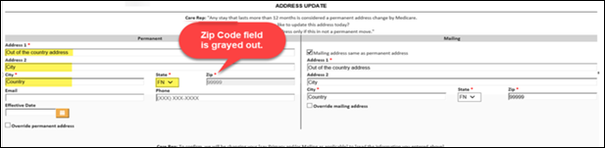
5 | Mailing/Temporary/Alternate Address Change |  |  |  | If the mailing address is the same as the Permanent (Home/Residential) address, check the Mailing address same as permanent address box to auto populate all fields.  If not populate all fields under the Mailing Address. An Asterisk (*) indicates a mandatory field.  - Address 1*: Street number and Street name (123 Main St.)  - Address 2: Apartment Number, Lot Number and C/O information (Apt 2, Lot 15, C/O John Deere)  - City*  - State* (if the move is a foreign move, select FN from the dropdown menu)  - Zip*  - Email  - Phone  - Calendar Icon. Only populate if the date is for a future permanent move.  Note:  - The address lines have a 30 character limit.  - Foreign addresses need to be populated as follows:  - Address 1*: Street address and Apt No (123 E Main St, Apt 1)  - Address 2: City/Town  - City*: Country Name  - State*: Select FN from the dropdown menu  - Zip will be grayed out  - Email  - Phone  - Calendar Icon. Only populate if the date is for a future permanent move.
6 | Confirm the address change(s) with the beneficiary and review the message on the screen to advise the beneficiary that if the mailing address is being used on a temporary basis, they will need to contact the plan to update their records when there is a change.  To confirm, we will be changing your [say Primary and/or Mailing as applicable] to [read the information you entered above].  - If Mailing is being updated, say: If this address is being used on a temporary basis, please contact us upon returning to your previous address so we may update our records.  - Do you wish to proceed?
6 | If... | Then...
6 | Yes | Select Yes radio button.  Note: The system will run the addresses through the US Postal Service Perfect Address database. This service will check the new address and provide suggestions if a typographical error was made, or if the address does not match the database.
6 | Yes | If the address... |  |  |  |  | Then...
6 | Yes | Matches the Perfect Address Database |  |  |  |  | - Select Accept and Continue.  - Proceed to Step 7.
6 | Yes | Does not Match the Perfect Address Database |  |  |  |  | If applicable, Do you want to overwrite existing address details with Standardized Address provided by Perfect Address?
6 | Yes |  |  |  |  |  | If… |  | Then...
6 | Yes |  |  |  |  |  | Yes, accept the recommendation |  | - Place a check on the Perfect Address line(s).  - Select Submit.  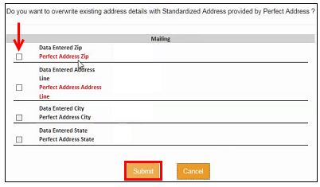  Note: If the Perfect Address is not selected, then the Override box will need to be selected.
6 | Yes |  |  |  |  |  | No, decline the recommendation |  | - Select Cancel.  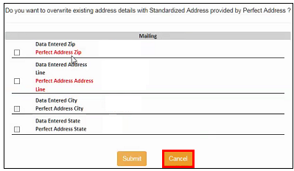  - Verify address with beneficiary.  - If correct, check the appropriate Override box on the address update screen.  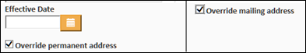
6 | Yes |  |  |  |  |  | Invalid Address - USPS information may not be up-to-date (Example: New street, new subdivision, etc.) |  | - Select OK.  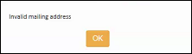  - Verify address with beneficiary.  - If correct, check the appropriate Override box on the address update screen.
6 | No | - Select No radio button  - Enter the following Comments in the pop up box: Beneficiary does not agree to address change due to <Reason>.  - If needed provided Legal Rep or POA (Full name, address, and phone number, and relationship to the beneficiary).  - Click Submit.  - Log out of the RxEnroll Care application.
7 | RxEnroll Care determines:
7 | If... |  |  | Then...
7 | New address is in area |  |  | The Address Update - In Area screen will display.  - Review the message with the beneficiary to let them know that their address has been updated.  - Proceed to Step 8.
7 | Address is out of area due to reporting a foreign address and the beneficiary is no longer eligible for a Medicare Plan |  |  | The OOA Disenrollment screen will display.  Note: For SilverScript EGWP beneficiaries, the OOA disenrollment screen will only display for a foreign address.  - Review the message displayed within RxEnroll Care with the beneficiary to advise them of their upcoming disenrollment.  - Leave comments to indicate what actions were taken and any pertinent information (mandatory)  Note: Enter appropriate comments into RxEnroll and copy and paste into the Participant Inquiry Tab in PeopleSafe.
7 | Beneficiary is an auto enrollee who has moved to a region below the benchmark |  |  | The Address Update - In Area screen will display.  - Review the message with the beneficiary to let them know that their address has been updated.  - Proceed to Step 8.  Refer to MED D – Over/Under the Benchmark.
7 | New enrollment is required for the beneficiary’s new region  OR  Beneficiary is an auto enrollee who has moved to a region above the benchmark |  |  | The New Enrollment Required screen will display  Review the message displayed within RxEnroll Care with the beneficiary indicating that a new enrollment is required to prevent a lapse in coverage.  Disenrollments are effective the first day of the next month. It is critically important that the beneficiary is aware that a new enrollment is needed when changing their permanent address near the end of the month.
7 |  |  |  | If beneficiary would like to ... |  |  |  | Then...
7 |  |  |  | Continue reenrollment in the new region |  |  |  | Select Yes. Warm Transfer to an Enrollment Agent at 1-800-882-9194 (For Internal Use Only).  Refer to: MED D - Guide to Transferring a Call  Note: Enter detailed comments into RxEnroll and copy and paste these notes into the Participant Inquiry Tab in PeopleSafe.
7 |  |  |  | Does not want to speak to an enrollment trained representative |  |  |  | Select No, member would like to be disenrolled in RxEnroll Care.  Review the message displayed in RxEnroll providing the beneficiary with the disenrollment effective date.  Note:  If the beneficiary agrees with the action to disenroll, select Continue with disenrollment.  - Enter detailed comments into RxEnroll and copy and paste these notes into the Participant Inquiry Tab in PeopleSafe.  If the beneficiary wishes to stay with the plan, for a new application to be completed, advise the beneficiary an enrollment application can be completed by:  - Visiting www.aetnamedicare.com.  - Call 1-800-633-4227 (1-800-MEDICARE) 24 hours a day, 7 days a week or visit www.medicare.gov to enroll. TTY users should call 1-877-486-2048.  - Phone number to provide to the beneficiary if requested is 1-833-606-0372. Advise the caller not to select Option 1 as this will return the caller to SilverScript Customer Care. State there will be two selections to make and provide the appropriate Options to select for each call type below:  - Current enrolled beneficiary: Select Option 2 and then Option 1
8 | Ask the beneficiary to allow you a few moments to update the other systems before you close the call or transfer the beneficiary to another department.
9 | Proceed to next section, Address Changes in the Participant Inquiry Tab.

Top of the Document

Address Changes in Participant Inquiry Tab

Perform the steps below:
Step | Action
1 | Determine which address the beneficiary is requesting to update.
1 | If… | Then…
1 | Temporary/Alternate | Proceed to next step.
1 | Permanent (Home/Residential)  OR  Mailing | Proceed to Step 3.
2 | Verify address(es) in the USPS Address Validation process:  - Access the United States Postal Service Look Up A Zip Code site: https://tools.usps.com/go/ZipLookupAction_input  - Enter address(es) provided by the caller  - Street Address  - City  - State  - Zip Code  - Click Find and a corrected address will be returned.  - Confirm with the caller that the returned address(es) are correct.  Note: Remember to always confirm address details, such as Apartment number.
2 | If… |  |  |  | Then…
2 | Confirms |  |  |  | Copy the address and then paste the address into the application.
2 | Does not agree that the address is correct |  |  |  | - Re-enter the information provided by the caller and repeat the process.  - If address still not located verify with beneficiary (USPS information may not be up-to-date)
3 | From the Participant Inquiry Tab on the Main Screen in PeopleSafe, click on the Change Contact Info button.  Result: The Contact Info screen is displayed.
4 | Verify if the beneficiary has an Alternative Address currently selected.
4 | If... |  |  |  |  | Then...
4 | Yes and the expiration date has passed |  |  |  |  | Proceed to the next step.
4 | Yes and the expiration date has NOT passed |  |  |  |  | - Delete the effective date and select Save.  - Proceed to the next step.
4 | No |  |  |  |  | Proceed to the next step.
5 | Click on the Add button on the left (middle of screen).  Note: The Contact Info screen can hold up to 10 (ten) addresses.  - If there are too many addresses on file and another address cannot be added, refer to Removing a Member’s Address.
6 | Select PRIMARY HOME (mailing) from the Address Type drop down menu.  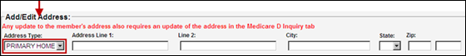
7 | Enter the following address information:  - Address Line 1  - Address Line 2  - City  - State (Foreign address use EU)  - Zip Code (Foreign Address use 99999)  CCR Process Note: Update the address as it is listed by USPS, including abbreviations.  Examples:  - Address Line 1: Street number and Street name (123 Main St.)  - Address Line 2: Apartment Number, Lot Number and C/O information (Apt 2, Lot 15, C/O John Deere)  - Military addresses, note the following:  - SSGT Kevin Taylor Unit 2050 Box 4190, APO AP 96278-2050  - Enter the address as normal with the following military specifics:  - City: APO or FPO or DPO  - State: AP  - Military states can be any of the following:  - AE - Armed Forces Europe, Middle East, Africa and Canada  - AA - Armed Forces Americas  - AP - Armed Forces Pacific
8 | Select the appropriate checkbox for the MOR Default field.  Ensure that the Apply Changes to Family box is NOT checked.
8 | If updating… |  |  | Then select…
8 | - Permanent (Home/Residential) Address  - Mailing Address |  |  | Primary
8 | - Temporary/Alternate Address |  |  | Alternate  - Enter the Effective and Expiration dates for the temporary address.  - Once the Expiration date has passed, the beneficiary’s Mailing Address will revert back to the MOR Default Primary Mailing Address on file.  - Single Use/Single Fill address enter the Effective and Expiration dates for same date.
9 | Select the appropriate MOR Change Reason via the drop-down menu.  Refer to the table below for definitions of choices.  Note: The most common Change Reasons are Legal Rep or Member Request.
9 | Change Reason |  | Definition
9 | Legal Rep |  | Legal Representative Request  Documentation must be on file that is valid under state law to support their legal authority to act on behalf of the patient. This may be a durable POA that was signed while the patient was still competent, or a court appointment of a guardian/custodian or some sort of legal documentation.
9 | Member Request |  | Member Request  Refers to the Plan Participant over the age of 18 who is covered on the plan (other than the cardholder)
10 | Click on the Save button.  Results:  - On the Change Info screen, the Address field will now be updated with the new address.  - Updated information will display on the Main Screen in the Participant Detail Address field.
11 | Under the Change Contact Info, update the beneficiary’s phone number and e-mail address if provided.  Refer to MED D - Email and Phone Number Changes.
11 | Update… | High Level Steps…
11 | Phone Number | Under Phone:  - Click Add.  - Select Type.  - Enter Phone Number.  - Select Daytime/Nighttime/Text Messages preference.  - Click on the Save button.
11 | Email | Under E-Mail Address:  - Enter E-mail.  - Click on the Update button.
11 | Results:  - On the Change Info screen, the Phone and E-mail field will now be updated with the new information.  - Updated information will display on the Main Screen in the Participant Detail Address field.

Top of the Document

Address Changes for Incarcerated Beneficiaries

Perform the steps below:
Step | Action...
1 | Check the box for: Note If the member is incarcerated, please check this box.  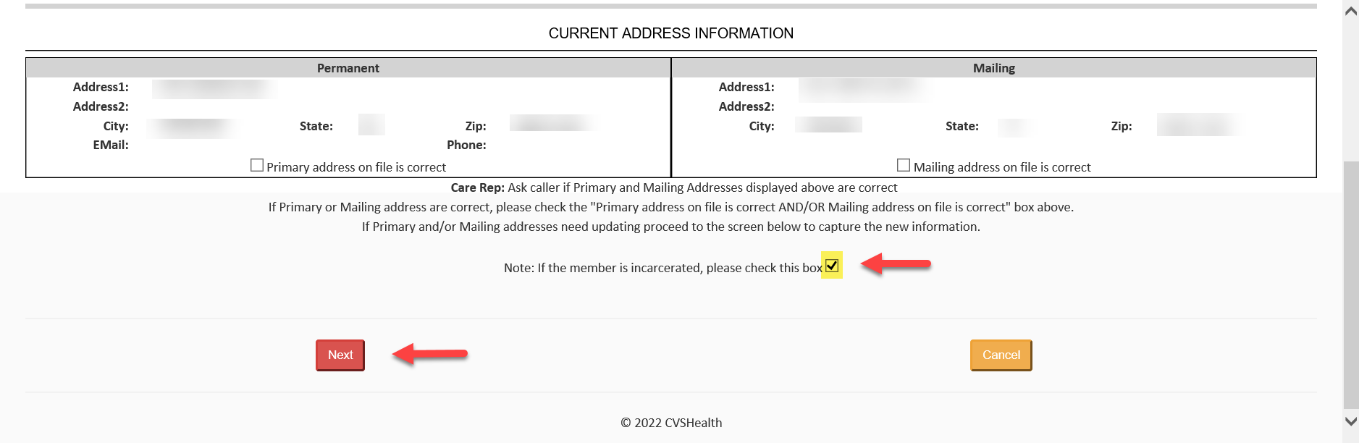  Result: The Address Update Incarceration screen will display.  - Confirm the caller’s identity and obtain the information requested on the Incarceration screen in RxEnroll.  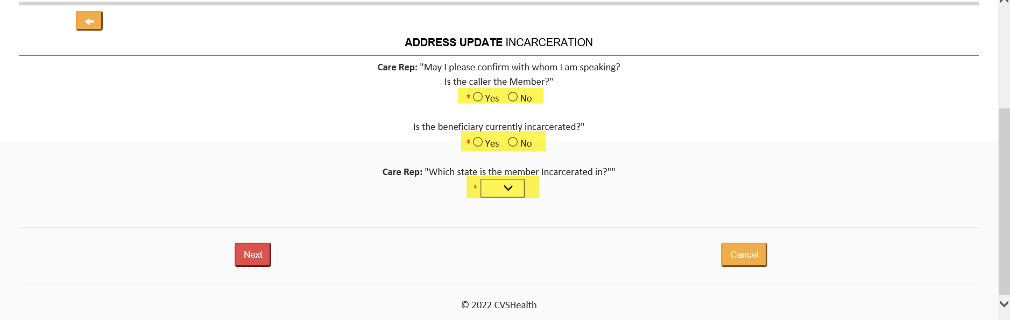  
2 | Enter the following information:  - Caller’s Name  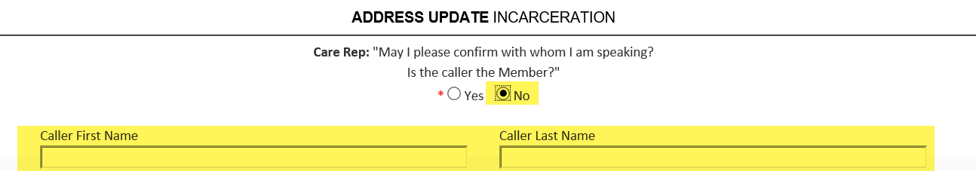  - Start date of Incarceration period. End date of incarceration period, if available.  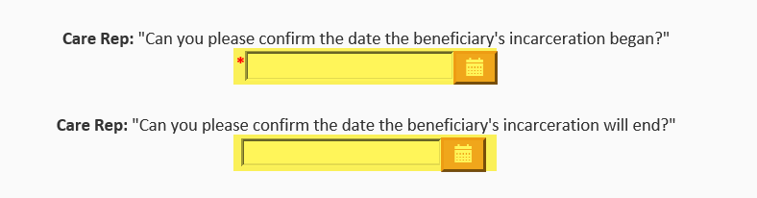  - State in which the beneficiary is incarcerated
3 | Review the message with the caller that the beneficiary will need to reenroll in a Part D plan upon release.
4 | Click Next.    Result: The RxEnroll Care main page will display and no further action is required.

Top of the Document

Note Templates

Use the chart below:
Scenario | Note Template
Permanent (Home/Residential) and/or Mailing Address | - Beneficiary’s PERMANENT/MAILING Address was changed on MM/DD/YYYY from <OLD Address> to <NEW Address> as requested by <caller>.  - If needed provided Legal Rep or POA (Full name, address, and phone number, and relationship to the beneficiary).
Mailing Address | - Beneficiary’s MAILING Address was changed on MM/DD/YYYY from <OLD Address> to <NEW Address> as requested by <caller>.  - If needed provided Legal Rep or POA (Full name, address, and phone number, and relationship to the beneficiary).
Temporary/Alternate Address  Example: I spend 6 (six) months at my summer residence and spend the other 6 (six) months in my winter residence. | - Beneficiary’s TEMPORARY Address was changed on MM/DD/YYYY from <OLD Address> to <NEW Address> as requested by <caller>. Advised the beneficiary when they want to update their mailing address or end the temporary mailing address, they will need to call back to provide that information to ensure they continue to receive any prescriptions and notifications.  - If needed provided Legal Rep or POA (Full name, address, and phone number, and relationship to the beneficiary).
Incarcerated | - Per <insert name of person who confirmed> beneficiary is currently incarcerated.
Currently living outside the United States (i.e. Canada) | - Beneficiary’s PERMANENT/MAILING Address was changed on MM/DD/YYYY from <OLD Address> to <NEW Address> as requested by <caller>. Include Phone Number and Email if provided.  - Beneficiary moved on (MM/YY) and will return (MM/YY) if provided  - If needed provided Legal Rep or POA (Full name, address, and phone number, and relationship to the beneficiary).  - Advised the beneficiary that the current residence is outside the United States and will result in disenrollment from the plan at the end of the month.  - Advised the beneficiary that they have a valid election period to enroll in the plan, in the month of and two months after their return to the United States. The beneficiary will not have coverage until a new enrollment is requested by the beneficiary

Top of the Document

Email and Phone Number Changes
Refer to MED D - Email and Phone Number Changes.

Top of the Document

Related Documents
Grievance Standard Verbiage (for use in Discussion with Beneficiary) section in MED D - Grievances Index

Parent SOP: CALL-0048: Medicare Part D Customer Care Call Center Requirements-CVS Caremark Part D Services, L.L.C.
Abbreviations/Definitions: Abbreviations / Definitions
Top of the Document
Not to Be Reproduced or Disclosed to Others without Prior Written Approval
ELECTRONIC DATA = OFFICIAL VERSION - PAPER COPY = INFORMATIONAL ONLY

